**Internship Project**

**DECISION SUPPORT SYSTEM**

Design a database called education and add the following tables;

1. tbl_districts

1. tbl_teachers

1. tbl_subjects

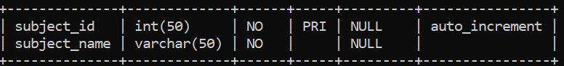

1. tbl_departments;

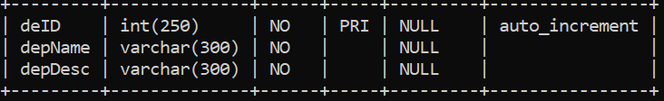

1. tbluser_reg;

Also design the following Front-end pages in JSP. Store all your project files under folder “Educ”

1. schools.jsp

1. teachers.jsp

